S O U T H B O R O U G H S O C I E T Y
HIGH STREET ORDER FORM
ALL ORDERS MUST BE RECEIVED BY MONDAY, 30TH NOVEMBER.
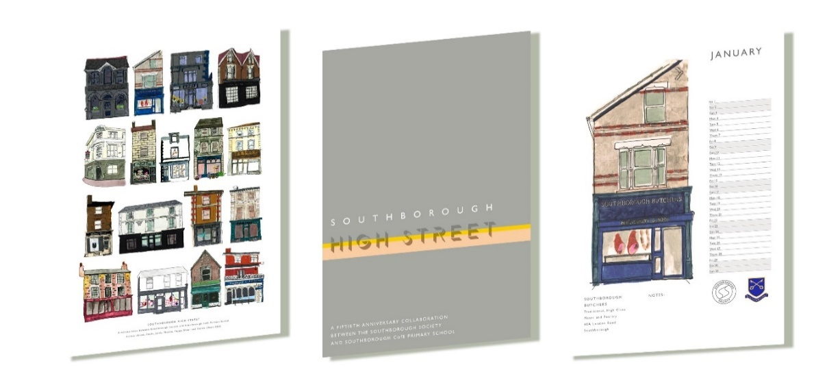

A3 Print on 220gsm paper @ £5 each.
A4 full colour ring bound 2021 calendar, @ £10 each.

Please complete this form and return it via email to thesouthboroughsociety@gmail.com
Surname: Forename:
Email:
Telephone:
Address:
Please indicate if you are the parent of a student at Southborough C of E Primary School (your purchases will be given to your child to take home) YES/NO
PRINT PRODUCT | QUANTITY | PRICE
………………………………………………. | ………………………………………………. | ………………………………………………
……………………………………………… | ………………………………………………. | ………………………………………………
TOTAL:
…………………
Make your payments to: The Southborough Society, NatWest Bank
Sort Code: 55-70-13 Account no: 06714684 Reference: High Street
Individual shop prints are available on request – please email thesouthboroughsociety@gmail.com

All proceeds will be shared by Southborough CofE Primary School and the Southborough Society (UK Registered Charity: 260979)

