Southborough Map
Fine Art Giclée Prints - ORDER FORM

Your Name _______________________________ Email _________________________________

Address ____________________________________________________________________

Post Code __________________________ Contact Number _______________________

Your order:

Size of print | No. of Prints | Price Per Print | Total to Pay
Large 51 x 35.5 cm |  | £80.00
Small 34 x 23.5cm |  | £60.00

Delivery
Postage - UK only - (tracked and signed for) | £7.00
Collection from 4 East Cliff Road, Tunbridge Wells, TN4 9AD | Free
Overseas – Please contact Elaine directly
Payment
Total print order | £
Delivery | £
Free | £
Total to pay | £

Please add tick payment method: Cash [ ] Cheque* [ ] Bank Transfer** [ ]

*Please make cheques payable to Mrs E J Gill
* Acc: 32251396, Sort code 40-44-37. Please reference payment with your surname

Additional Information
Please return completed order forms with payment via email elaine.gill@live.co.uk or by post to
Elaine Gill Art & Illustration, 4 East Cliff Road, Tunbridge wells, Kent, TN4 9AD.
On receipt will confirm collection times.
All personal information provided will not be forwarded to any third party or used in any other format other than to contact you regarding your order.

About the artist
Elaine specialises in illustrative architectural drawings, paying particular attention to fine detail and line. Her work has taken on many interesting projects and collaborations, these include, the platform 2 project, books, publications, illustrated town and tourism maps, as well as commissions with both the National Trust and Woodland Trust.

‘Your story illustrated’ is a very special and specific style of Elaine’s work, to learn more,
view examples of her work and upcoming events visit www.elainegill.co.uk

Contact - elaine.gill@live.co.uk www.elainegill.co.uk Instagram @elainejgill
Map of Southborough, Kent
Fine art Giclee Prints

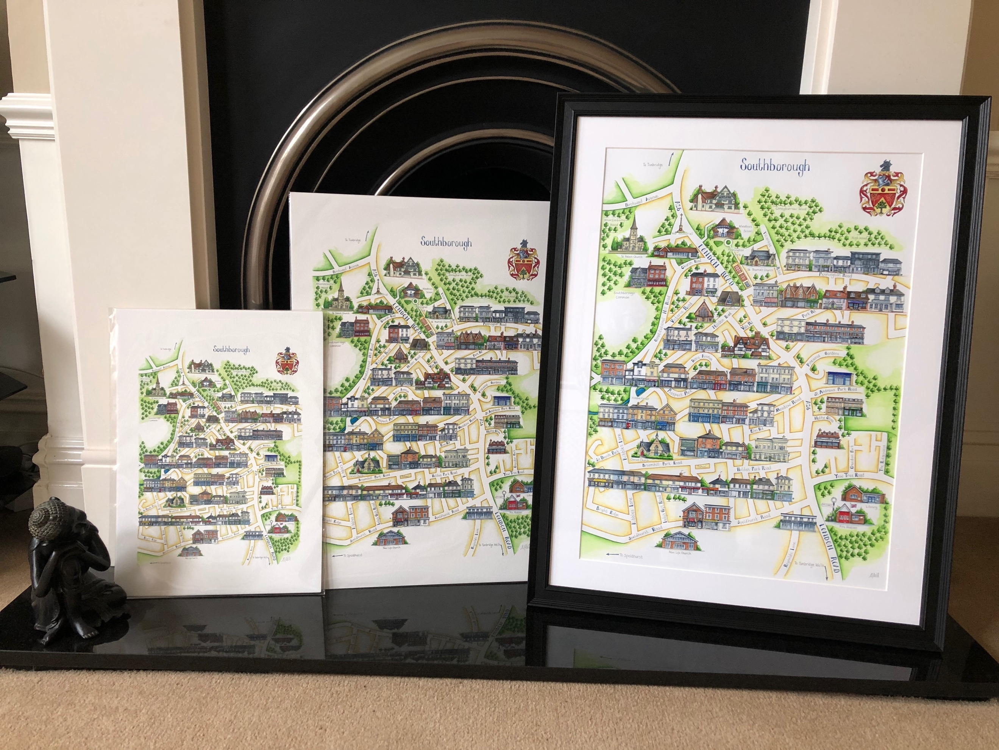
Large Print £80 (Image size 51 x 35.5cm)
Small Print £60 (Image size 34 x 23.5cm)

Your home Illustrated
There is a little space to personalise the map with your home and address £25

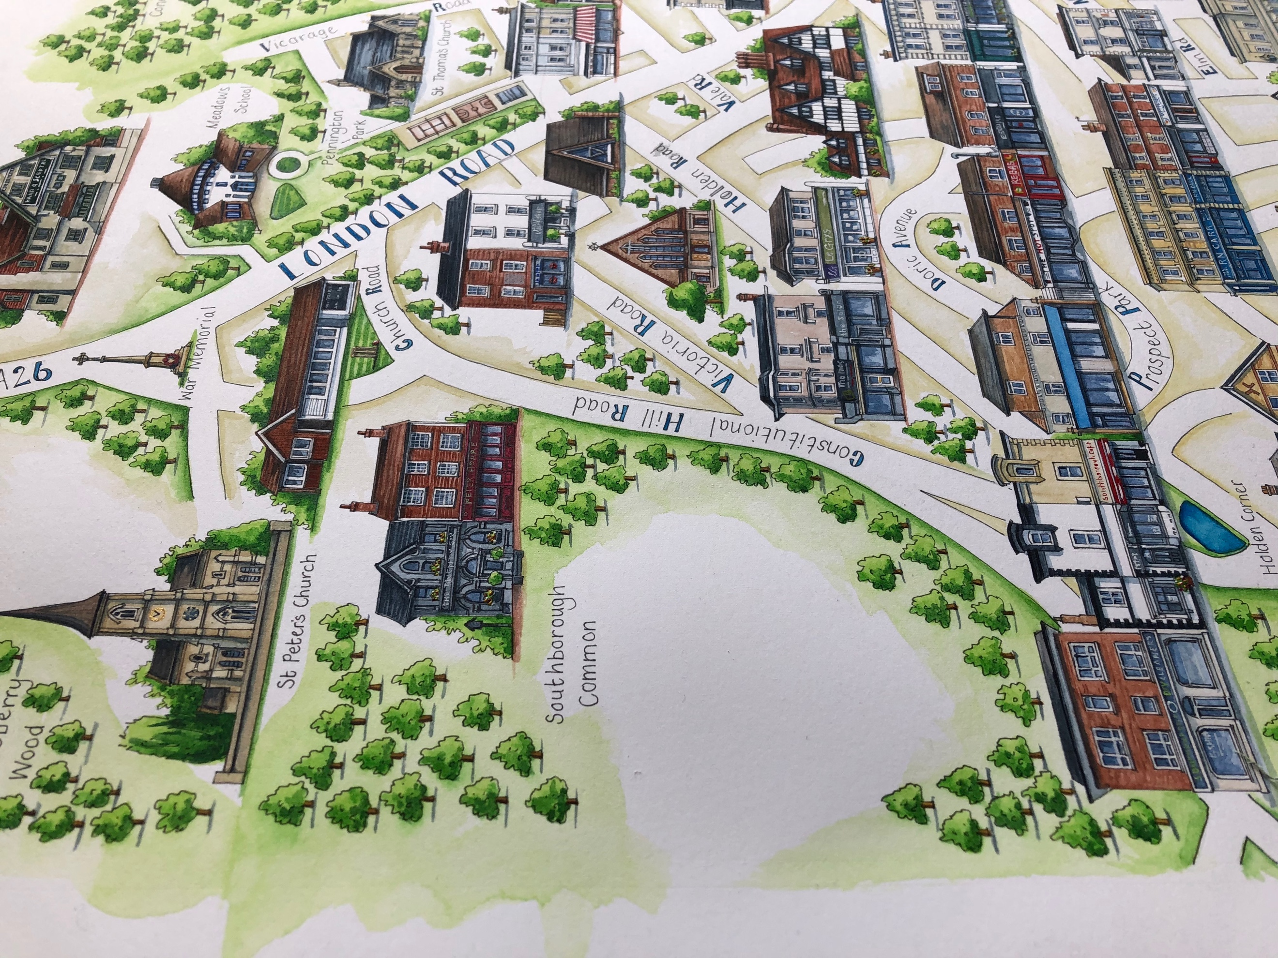

Contact Elaine.gill@live.co.uk
www.elainegill.co.uk
Instagram -@elainejgill

If you would like to arrange a visit, the kettle is always on!

